* **Tips to answer question**

1. **Analyze the requirements:**

Scenario: resiliency, cost-effectiveness, retention policy

Constraints: 24-hour access, permanent deletion

Spot specific features: versioning enabled, event notifications

1. **Map Requirements to AWS Services and Features**

Core Service

For S3, understand versioning, lifecycle rules, storage classes, and event notifications.

**S3 Lifecycle rules** are ideal for automating object deletion based on **age**.

1. Eliminate incorrect options

unnecessary complexity (Lambda), no AWS best practices

1. Leverage AWS Best Practices

Cost-Effective

**Built-In** Automation

Resiliency

1. Practice Common Scenarios

**S3:** Lifecycle policies, storage classes, event notifications, versioning.

**IAM:** Policies, roles, least privilege.

**CloudFormation:** Drift detection, change sets.

**EC2:** Instance types, security groups.

* **Example Application:**

ZARBIO ROMULO ORDONEZ DAVILA-342789844-AWS Certified Developer – Associate (E) - 3.pdf – Q3:

**Requirement**: "Objects must be permanently removed 1 year after creation."

**Key Considerations**: S3 versioning, automation of retention.

**Mapping to AWS Features**: S3 Lifecycle rules can handle both current and noncurrent versions with minimal effort.

**Eliminate Options:**

Remove solutions involving custom Lambda code (adds complexity).

Focus on built-in features like lifecycle rules.

* **Questions**
* Which type of scaling is provided by Amazon EC2 Auto Scaling?

1. Vertical
2. **Horizontal**

* **AWS Certified Developer Associate Exam Practice Questions 2025 DVA-C02 - Part 1 #aws**

<https://www.youtube.com/watch?v=Q19XCPSdjOE>

65 questions

50/65 scored question

15/65 unscored question

no negative marking

1. B

Domain: Development with AWS Services

<https://docs.aws.amazon.com/apigateway/latest/developerguide/stage-variables.html>

1. **B,C**



Domain: Deployment

<https://docs.aws.amazon.com/apigateway/latest/developerguide/aws-api-gateway-stage-variables-reference.html#stage-variables-in-integration-HTTP-uris>

1. **E**

Domain: Deployment

<https://docs.aws.amazon.com/secretsmanager/latest/userguide/hardcoded-db-creds.html>

1. D

Domain: Troubleshooting and Optimization

<https://docs.aws.amazon.com/AWSSimpleQueueService/latest/SQSDeveloperGuide/FIFO-queues.html>

1. A

Domain: Deployment

1. **B,C**



Domain: Development with AWS Services

<https://aws.amazon.com/elasticloadbalancing/>

<https://docs.aws.amazon.com/elasticloadbalancing/latest/userguide/how-elastic-load-balancing-works.html>

1. A

Domain: Troubleshooting and Optimization

<https://aws.amazon.com/xray/>

1. A

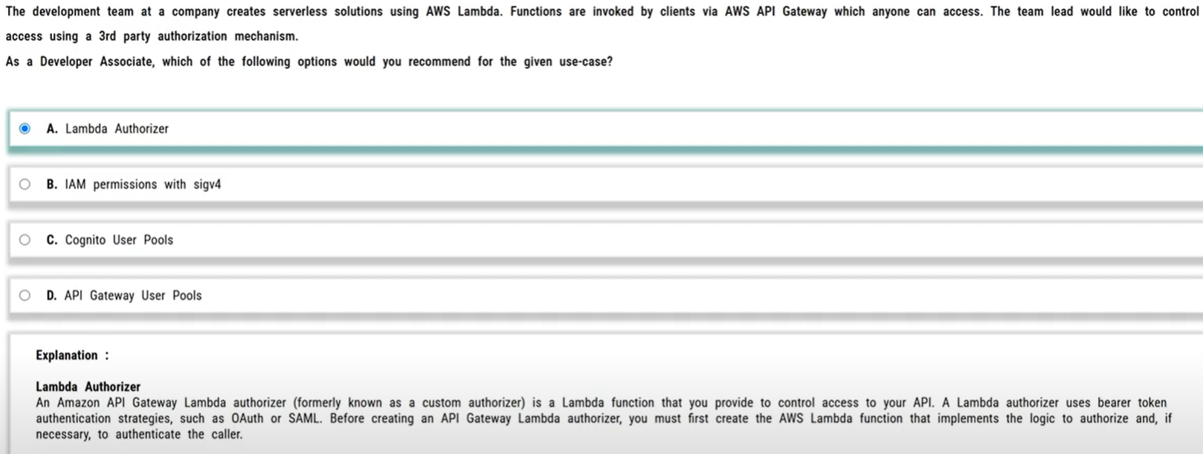

Domain: Security

<https://docs.aws.amazon.com/apigateway/latest/developerguide/apigateway-use-lambda-authorizer.html>

1. A

Domain: Development with AWS Services

<https://docs.aws.amazon.com/elasticbeanstalk/latest/dg/ebextensions.html>

1. D

Domain: Deployment

<https://docs.aws.amazon.com/organizations/latest/userguide/orgs_introduction.html>

<https://docs.aws.amazon.com/AWSCloudFormation/latest/UserGuide/stacksets-concepts.html>

<https://docs.aws.amazon.com/AWSCloudFormation/latest/UserGuide/what-is-cfnstacksets.html>

1. **B**



Domain: Development with AWS Services

<https://docs.aws.amazon.com/AWSEC2/latest/UserGuide/reserved-instances-scope.html>

<https://docs.aws.amazon.com/AWSEC2/latest/UserGuide/ec2-reserved-instances.html>

1. **C,D**



Domain: Troubleshooting and Optimization

<https://aws.amazon.com/kinesis/data-streams/>

<https://aws.amazon.com/kinesis/data-streams/faqs/>

1. **A**

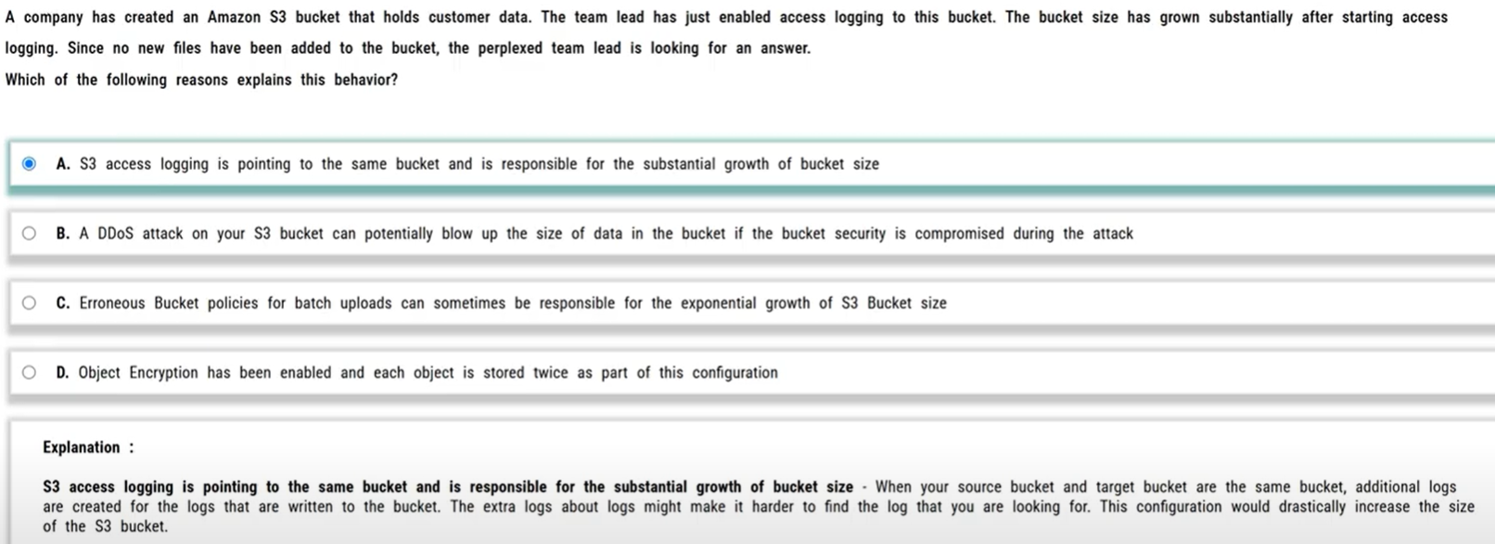

Domain: Troubleshooting and Optimization

<https://docs.aws.amazon.com/AmazonS3/latest/dev/ServerLogs.html>

<https://docs.aws.amazon.com/AmazonS3/latest/user-guide/set-permissions.html>

1. B

Domain: Security

<https://docs.aws.amazon.com/AWSEC2/latest/UserGuide/iam-roles-for-amazon-ec2.html>

1. C



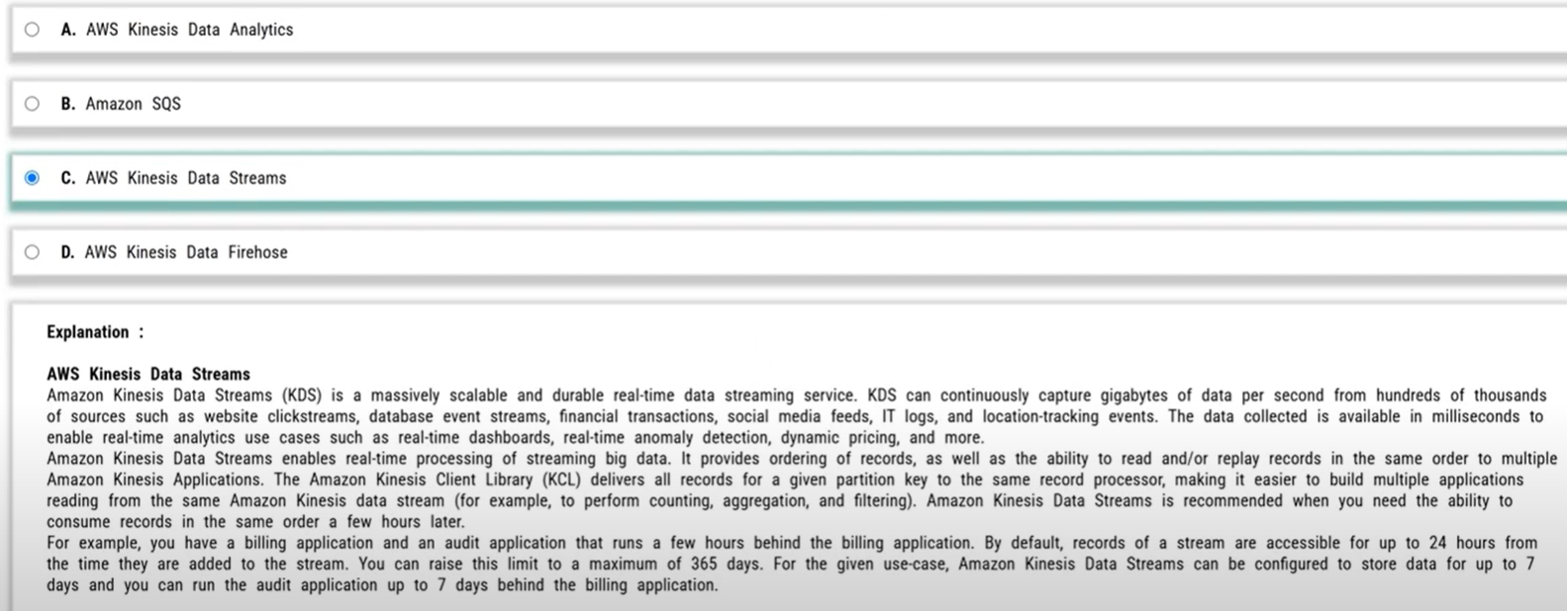

Domain: Development with AWS Services

<https://aws.amazon.com/kinesis/data-streams/faqs/>

<https://aws.amazon.com/kinesis/data-firehose/faqs/>

<https://aws.amazon.com/kinesis/data-analytics/faqs/>

1. **A**

Domain: Development with AWS Services

<https://docs.aws.amazon.com/AmazonCloudWatch/latest/logs/S3Export.html>

1. **C**

Domain: Development with AWS Services

<https://docs.aws.amazon.com/AWSSimpleQueueService/latest/SQSDeveloperGuide/FIFO-queues.html>

<https://docs.aws.amazon.com/AWSSimpleQueueService/latest/SQSDeveloperGuide/using-messagegroupid-property.html>

1. **C**

Domain: Troubleshooting and Optimization

<https://docs.aws.amazon.com/AmazonCloudWatch/latest/events/WhatIsCloudWatchEvents.html>

<https://docs.aws.amazon.com/codepipeline/latest/userguide/detect-state-changes-cloudwatch-events.html>

1. **A**



Domain: Development with AWS Services

<https://aws.amazon.com/dynamodb/dax/>

<https://aws.amazon.com/blogs/networking-and-content-delivery/amazon-s3-amazon-cloudfront-a-match-made-in-the-cloud/>

<https://aws.amazon.com/elasticache/redis/>

1. D

Domain: Development with AWS Services

<https://docs.aws.amazon.com/elasticbeanstalk/latest/dg/concepts.html>

<https://docs.aws.amazon.com/elasticbeanstalk/latest/dg/using-features-managing-env-tiers.html>

1. **D,E**

Domain: Security

<https://aws.amazon.com/xray/faqs/>

<https://docs.aws.amazon.com/xray/latest/devguide/xray-daemon-configuration.html>

1. **A**

Domain: Development with AWS Services

<https://docs.aws.amazon.com/AWSCloudFormation/latest/UserGuide/intrinsic-function-reference.html>

<https://docs.aws.amazon.com/AWSCloudFormation/latest/UserGuide/intrinsic-function-reference-getatt.html>

1. **C**

Domain: Deployment

<https://docs.aws.amazon.com/codedeploy/latest/userguide/deployment-groups.html>

1. D

Domain: Troubleshooting and Optimization

<https://docs.aws.amazon.com/autoscaling/ec2/userguide/AutoScalingGroup.html>

<https://docs.aws.amazon.com/autoscaling/ec2/userguide/detach-instance-asg.html>

1. **A,C**

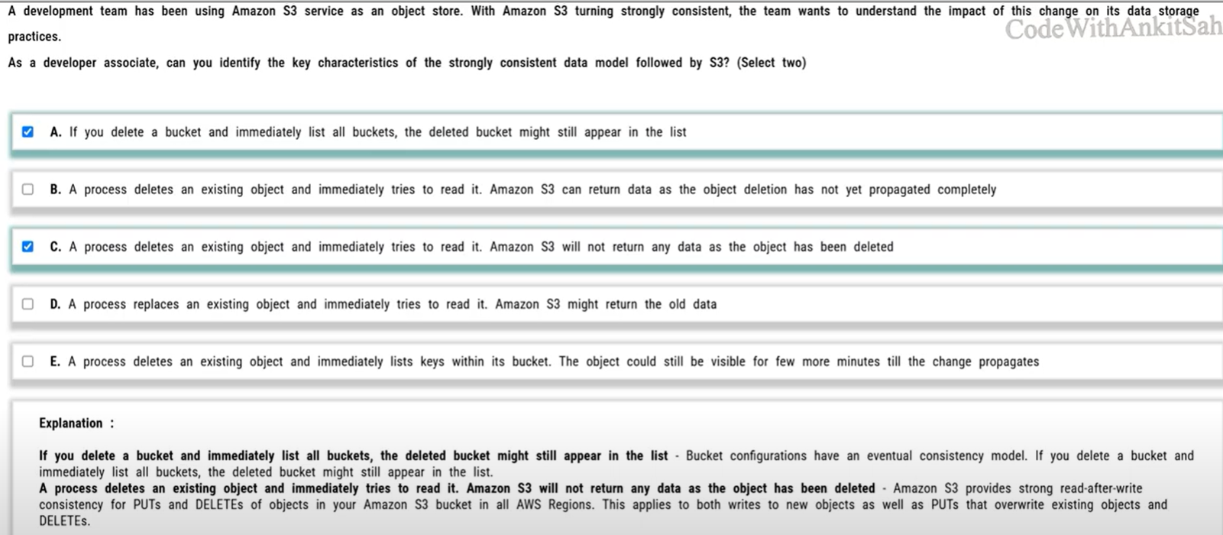

Domain: Troubleshooting and Optimization

<https://docs.aws.amazon.com/AmazonS3/latest/userguide/Welcome.html#ConsistencyModel>

1. C

Domain: Troubleshooting and Optimization

<https://docs.aws.amazon.com/AWSSimpleQueueService/latest/SQSDeveloperGuide/sqs-dead-letter-queues.html>

1. **D**

Domain: Development with AWS Services

<https://docs.aws.amazon.com/lambda/latest/dg/running-lambda-code.html>

<https://docs.aws.amazon.com/lambda/latest/dg/best-practices.html#function-configuration>

1. **A**



Domain: Security

<https://docs.aws.amazon.com/apigateway/latest/developerguide/apigateway-resource-policies-examples.html#apigateway-resource-policies-cross-account-example>

<https://docs.aws.amazon.com/apigateway/latest/developerguide/apigateway-authorization-flow.html>

1. **C**

Domain: Troubleshooting and Optimization

<https://docs.aws.amazon.com/AWSSimpleQueueService/latest/SQSDeveloperGuide/sqs-long-polling.html>

<https://aws.amazon.com/sqs/faqs/>

1. B

Domain: Development with AWS Services

<https://docs.aws.amazon.com/streams/latest/dev/key-concepts.html>

<https://docs.aws.amazon.com/streams/latest/dev/kinesis-record-processor-scaling.html>

1. B,C

Domain: Development with AWS Services

<https://docs.aws.amazon.com/apigateway/latest/developerguide/api-gateway-caching.html#invalidate-method-caching>

<https://aws.amazon.com/api-gateway/faqs/#Throttling_and_Caching>

1. D

Domain: Development with AWS Services

<https://docs.aws.amazon.com/AmazonS3/latest/dev/uploadobjusingmpu.html>

<https://docs.aws.amazon.com/AmazonS3/latest/dev/transfer-acceleration.html>

1. **A,C**



Domain: Development with AWS Services

<https://docs.aws.amazon.com/serverless-application-model/latest/developerguide/sam-cli-command-reference-sam-local-invoke.html>

<https://aws.amazon.com/blogs/aws/aws-serverless-application-model-sam-command-line-interface-build-test-and-debug-serverless-apps-locally/>

<https://docs.aws.amazon.com/cli/latest/userguide/cli-configure-files.html>

1. **C**

Domain: Development with AWS Services

<https://docs.aws.amazon.com/apigateway/latest/developerguide/setup-http-integrations.html>

<https://docs.aws.amazon.com/apigateway/latest/developerguide/api-gateway-api-integration-types.html>

1. **C**

Domain: Development with AWS Services

<https://docs.aws.amazon.com/amazondynamodb/latest/developerguide/Streams.html>

[https://docs.aws.amazon.com/amazondynamodb/latest/developerguide/Streams.KCLAdapter.html](https://docs.aws.amazon.com/amazondynamodb/latest/developerguide/Streams.html)

[https://docs.aws.amazon.com/amazondynamodb/latest/APIReference/API_StreamSpecification.html](https://docs.aws.amazon.com/amazondynamodb/latest/developerguide/Streams.html)

1. **C**

Domain: Security

<https://docs.aws.amazon.com/kms/latest/developerguide/concepts.html#enveloping>

<https://docs.aws.amazon.com/kms/latest/developerguide/overview.html>

1. A

Domain: Development with AWS Services

<https://docs.aws.amazon.com/AWSSimpleQueueService/latest/SQSDeveloperGuide/using-messagededuplicationid-property.html>

<https://docs.amazonaws.cn/en_us/AWSSimpleQueueService/latest/SQSDeveloperGuide/FIFO-queues.html#FIFO-queues-exactly-once-processing>

<https://aws.amazon.com/blogs/developer/how-the-amazon-sqs-fifo-api-works/>

1. C

Domain: Development with AWS Services

<https://docs.aws.amazon.com/apigateway/latest/developerguide/api-gateway-method-settings-method-request.html#setup-method-request-model>

<https://docs.aws.amazon.com/apigateway/latest/developerguide/api-gateway-api-integration-types.html>

<https://docs.aws.amazon.com/apigateway/latest/developerguide/set-up-lambda-proxy-integrations.html#api-gateway-simple-proxy-for-lambda-input-format>

1. A

Domain: Development with AWS Services

<https://docs.aws.amazon.com/amazondynamodb/latest/developerguide/DynamoDBMapper.OptimisticLocking.html>

<https://docs.aws.amazon.com/amazondynamodb/latest/developerguide/Introduction.html>

<https://docs.aws.amazon.com/amazondynamodb/latest/developerguide/HowItWorks.ReadWriteCapacityMode.html>

<https://docs.aws.amazon.com/aws-sdk-php/v2/api/class-Aws.DynamoDb.Session.LockingStrategy.PessimisticLockingStrategy.html>

1. **D**

Domain: Troubleshooting and Optimization

<https://docs.aws.amazon.com/xray/latest/devguide/xray-daemon-ec2.html>

<https://docs.aws.amazon.com/xray/latest/devguide/xray-daemon.html#xray-daemon-permissions>

1. C,E

Domain: Development with AWS Services

<https://docs.aws.amazon.com/lambda/latest/dg/resource-model.html>

[https://aws.amazon.com/lambda/pricing/](https://docs.aws.amazon.com/lambda/latest/dg/resource-model.html)

[https://docs.aws.amazon.com/lambda/latest/dg/invocation-scaling.html](https://docs.aws.amazon.com/lambda/latest/dg/resource-model.html)

1. A

Domain: Security

<https://docs.aws.amazon.com/cognito/latest/developerguide/managing-security.html>

<https://docs.aws.amazon.com/cognito/latest/developerguide/cognito-user-identity-pools.html>

1. **C**

Domain: Development with AWS Services

<https://docs.aws.amazon.com/cognito/latest/developerguide/cognito-sync.html>

<https://docs.aws.amazon.com/cognito/latest/developerguide/push-sync.html>

1. B,E

Domain: Development with AWS Services

<https://docs.aws.amazon.com/amazondynamodb/latest/developerguide/SecondaryIndexes.html>

<https://docs.aws.amazon.com/amazondynamodb/latest/developerguide/GSI.html>

1. C

Domain: Deployment

<https://aws.amazon.com/premiumsupport/knowledge-center/deploy-codecommit-elastic-beanstalk/>

<https://docs.aws.amazon.com/elasticbeanstalk/latest/dg/eb-cli-codecommit.html>

1. A

Domain: Troubleshooting and Optimization

[https://aws.amazon.com/premiumsupport/knowledge-center/build-python-lambda-deployment-package](https://aws.amazon.com/premiumsupport/knowledge-center/build-python-lambda-deployment-package/)

<https://docs.aws.amazon.com/lambda/latest/dg/python-package.html>

1. B

Domain: Troubleshooting and Optimization

<https://aws.amazon.com/blogs/architecture/best-practices-for-developing-on-aws-lambda/>

<https://docs.aws.amazon.com/lambda/latest/dg/configuration-console.html>

1. D

Domain: AWS Application Integration

1. A

Domain: Development with AWS Services

<https://docs.aws.amazon.com/codedeploy/latest/userguide/deployments.html>

1. C

Domain: AWS Analytics

<https://docs.aws.amazon.com/athena/latest/ug/what-is.html>

1. B

Domain: AWS Security, Identity, & Compliance

<https://docs.aws.amazon.com/secretsmanager/latest/userguide/intro.html>

1. D

Domain: Development with AWS Services

<https://docs.aws.amazon.com/autoscaling/ec2/userguide/what-is-amazon-ec2-auto-scaling.html>

<https://docs.aws.amazon.com/autoscaling/ec2/userguide/LaunchConfiguration.html>

1. C

Domain: AWS Networking & Content Delivery

<https://docs.aws.amazon.com/apigateway/latest/developerguide/canary-release.html>

1. B

Domain: Development with AWS Services

<https://docs.aws.amazon.com/lambda/latest/dg/services-cloudwatchevents.html>

1. A

Domain: AWS Application Integration

<https://docs.aws.amazon.com/AWSSimpleQueueService/latest/SQSDeveloperGuide/welcome.html>

1. **A**

Domain: AWS Application Integration

<https://docs.aws.amazon.com/streams/latest/dev/kinesis-record-processor-scaling.partial.html>

<https://docs.aws.amazon.com/streams/latest/dev/developing-consumers-with-kcl.html>

1. A

Domain: Development with AWS Services

<https://docs.aws.amazon.com/AmazonECS/latest/developerguide/task-placement-constraints.html>

1. B

Domain: AWS Security, Identity, & Compliance

<https://aws.amazon.com/blogs/security/how-to-use-bucket-policies-and-apply-defense-in-depth-to-help-secure-your-amazon-s3-data/>

1. **A**

Domain: AWS Storage

<https://docs.aws.amazon.com/AmazonS3/latest/dev/transfer-acceleration.html>

1. **D**

Domain: AWS Networking & Content Delivery

<https://docs.aws.amazon.com/lambda/latest/dg/troubleshooting-networking.html>

<https://docs.aws.amazon.com/amazondynamodb/latest/developerguide/vpc-endpoints-dynamodb.html>

1. **C**

Domain: Development with AWS Services

<https://docs.aws.amazon.com/apigateway/latest/developerguide/set-up-stages.html>

1. D

Domain: AWS Security, Identity, & Compliance

<https://docs.aws.amazon.com/cognito/latest/developerguide/cognito-user-identity-pools.html>

1. B

Domain: AWS Storage

<https://docs.aws.amazon.com/AmazonS3/latest/dev/transfer-acceleration.html>

1. D

Domain: Development with AWS Services

<https://docs.aws.amazon.com/amazondynamodb/latest/developerguide/specifying-conditions.html>

<https://docs.aws.amazon.com/amazondynamodb/latest/developerguide/using-identity-based-policies.html>

1. C

Domain: Development with AWS Services

<https://docs.aws.amazon.com/lambda/latest/dg/configuration-layers.html>

* **AWS Certified Developer Associate DVA-C02 Exam Question and Answers | Pass DVA-C02 Exam**

<https://www.youtube.com/watch?v=IVc0mgzvLKE>

3, 5, 7, 11, 12, 14, 16, 22, 25, 26, 29, 40

* **AWS-Certified-Developer-Associate_Sample-Questions_ES.pdf**

<https://explore.skillbuilder.aws/files/a/w/aws_prod1_docebosaas_com/1737644400/pbWVerSabSMTAb8jkcW8Mg/item/9bc5c323e84ed0b43c11ae06a25227492abc595de5cb5ceb64a68734bafc5774.pdf?enhanced_signature=oRzi4pGc3pEnvnIetOEU4fBe2x-b5Xqv-6JV9y3SIU4>

**4, 6, 8, 9**

* **Crack AWS DVA-C02 Exam in 6 Hours | AWS Certified Developer - Associate | Free PDF | Complete Guide!**

<https://www.youtube.com/watch?v=FAogPOeK5o4>

* **AWS Developer Associate (DVA-C02) Exam Dumps & Questions 2024**

<https://www.youtube.com/watch?v=tie_QNqn504>

* **Ace AWS DVA-C02: 200 Exam Questions Part 1 | Developer Associate | Detailed Explanations | #tricks**

<https://www.youtube.com/watch?v=xpo8CIc2Pn4>

* **AWS Certified Developer - Associate DVA-C02 Actual Exam Questions \*\***

<https://www.examtopics.com/exams/amazon/aws-certified-developer-associate-dva-c02/view/>

* **Notes**

